IDEATION PHASE
BRAINSTORM & IDEA PRIORITIZATION TEMPLATE
DATE | 24-09-2026
TEAM ID | SWTID-2026-2737
PROJECT NAME | AI WeatherWise API
MAXIMUM MARKS | 4 Marks

Brainstorm & Idea Prioritization Template:
Brainstorming is a collaborative ideation technique used to generate a large number of possible solutions before evaluating them. In this project, the team discusses the problem of early diabetes prediction, lists possible ideas, groups related ideas, and prioritizes the ideas according to their importance and feasibility.
The process follows the reference structure: define the problem, brainstorm ideas, group similar ideas, and prioritize the most useful solutions.

Step-1: Team Gathering, Collaboration and Select the Problem Statement

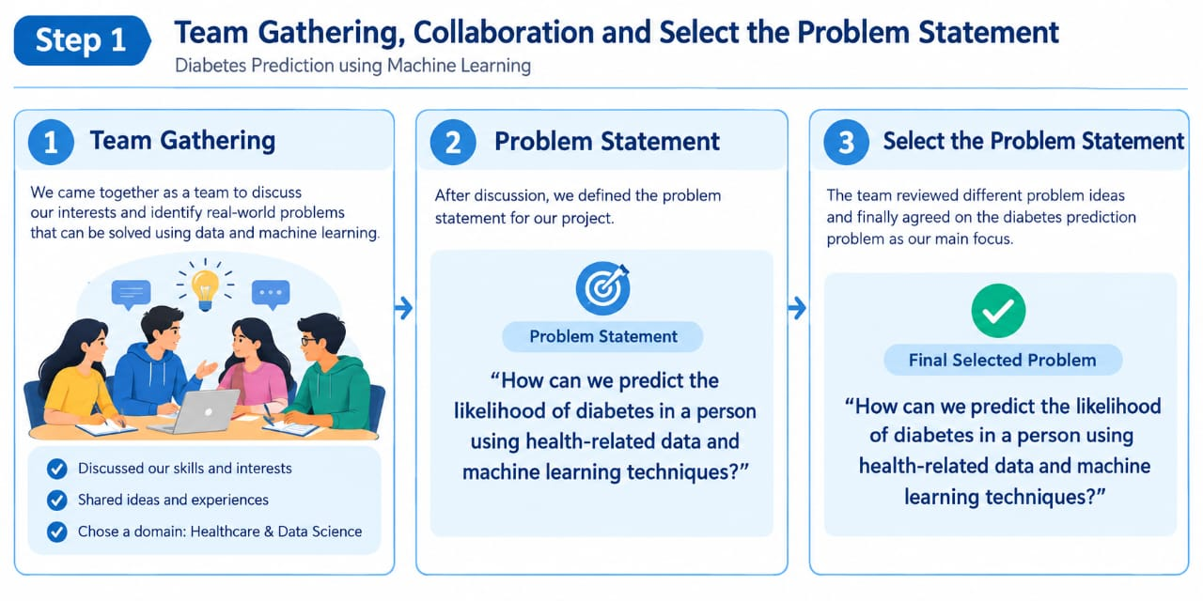

Step-2: Brainstorm, Idea Listing and Grouping
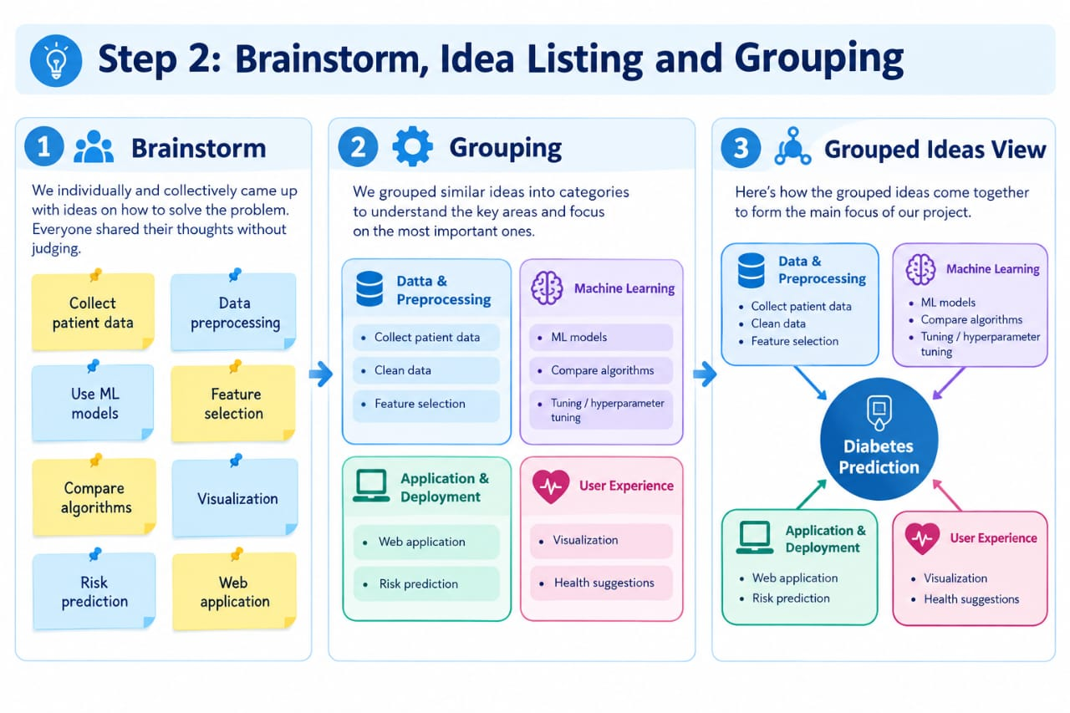
Step-3: Idea Prioritization

